1. WAP to create a simple calculator program that takes user input for two numbers and an operator (+, -, \*, /) and performs the corresponding arithmetic operation using conditional statements.

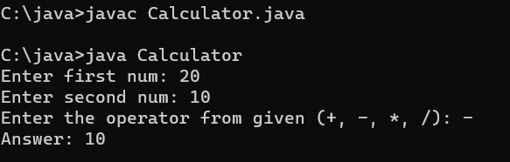

2. Create a class named Book with attributes title, author, ISBN, and price. Include methods to get and set the attributes.

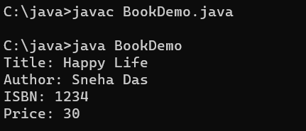

3. Create a class named Employee with attributes name, employeeId, designation, and salary.   Include a method calculateBonus() that returns 5% of the salary as bonus

